PSIRF planning – Inpatient falls

Introduction

The Patient Safety Incident Response Framework (PSIRF) is a new approach to learning from safety events in healthcare. It is a move away from a simple reactive approach to learning and improvement towards an approach that balances proportional proactive responses alongside learning from past events.

PSIRF moves away from linear cause and effect analysis (RCA) to a systems-based approach to learning that recognises that outcomes in complex systems such as health and social care result from the interaction of multiple factors – learning should not focus on uncovering a (root) cause, but instead should explore multiple contributory factors.

Under PSIRF, those leading the patient safety agenda within provider organisations, together with internal and external stakeholders (including Patient Safety Partners, commissioners, NHS England, regulators, Local Healthwatch, Medical Examiners, etc), decide how to respond to patient safety events and emerging issues based on the need to generate insight to inform safety improvement where it matters most. Key issues must first be identified and described as part of planning activities before an organisation agrees how it intends to respond to maximise learning and improvement.

PSIRF planning is captured by the cycle illustrated below. More information is provided in the [Guide to responding proportionately to patient safety incident](https://www.england.nhs.uk/wp-content/uploads/2022/08/B1465-3.-Guide-to-responding-proportionately-to-patient-safety-incidents-v1-FINAL.pdf) as well as in the patient safety incident response [plan template](https://view.officeapps.live.com/op/view.aspx?src=https%3A%2F%2Fwww.england.nhs.uk%2Fwp-content%2Fuploads%2F2022%2F08%2FB1465-8.-Patient-safety-incident-response-plan-template-v1-FINAL.docx&wdOrigin=BROWSELINK).

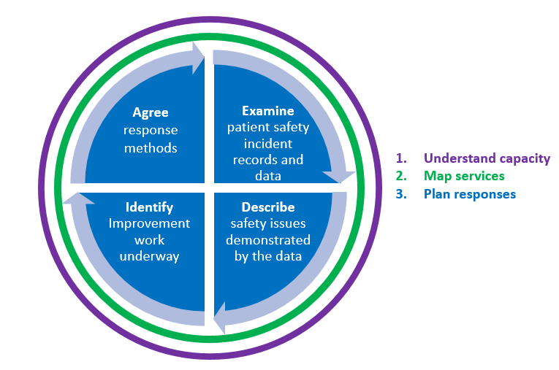

Falls are the most commonly reported patient safety event with around 250,000 occurring in inpatient settings in England every year. Falls are not random events but occur due to the presence of fall risk factors. Evidence suggests that all inpatients aged over 65 should have a multi-factorial fall risk factor assessment to identify fall risk factors and prompt tailored interventions. When falls do occur, prompt and effective post-fall management should be delivered. Aligned with PSIRF principles, responses to falls should be proportionate based on the potential for new learning and improvement and should focus on exploring multiple contributory factors.

To learn from falls and improve patient safety, the response should seek to understand how fall prevention is managed at an organisational, unit/ward and patient level using multi-disciplinary input.

PSIRF does not change:

* Any reporting requirements or expectations to record patient safety events.
* The need to engage those affected by patient safety incidents (including patients, families, and staff) and to uphold the Duty of Candour. See PSIRF supporting guidance [B1465-2.-Engaging-and-involving...-v1-FINAL.pdf (england.nhs.uk)](https://www.england.nhs.uk/wp-content/uploads/2022/08/B1465-2.-Engaging-and-involving...-v1-FINAL.pdf) for further information.

Before planning

**Understand capacity.**

Trusts must be able to describe their capacity to respond to inpatient falls for learning and improvement.

The [patient safety incident response standards](https://www.england.nhs.uk/publication/patient-safety-incident-response-framework-and-supporting-guidance/) describe how patient safety incident responses should be resourced, including the training and competencies those undertaking these responses require.

**Map their services.**

Organisations deliver different services and pathways and there are often organisations within organisations. Mapping all the services and teams involved in falls prevention and management will help ensure that the shape and structure of an organisation’s plan reflects patient safety concerns for the variety of services offered. Different responses are likely to be required on some wards/units or depend on the acuity of the setting (for example an intermediate care compared to an acute setting). Responses may vary depending on the frequency of falls, the frequency of injurious falls and the staffing levels/skill mix.

Planning guidance

Planning how to respond to patient safety incidents is a collaborative process and should involve a range of stakeholders. Specifically, to inpatient falls it is suggested that stakeholders include representatives from safety teams, nursing, medical, allied health professionals, and estates. Ideally stakeholders will include those involved in frontline patient care as well as those with leadership roles and consideration should be given to including patient representation. Trusts should have a falls steering group that meets quarterly who should be involved in the development of responses.

More guidance on who should be included can be found in the [Patient Safety Incident Response Framework supporting guidance](https://www.england.nhs.uk/wp-content/uploads/2022/08/B1465-3.-Guide-to-responding-proportionately-to-patient-safety-incidents-v1-FINAL.pdf).

There are four steps in the planning response:

1. Examine patient safety incident records and safety data.
2. Describe safety issues demonstrated by the data.
3. Identify improvement work underway.
4. Agree response methods.

Examine patient safety incident records and safety data.

Organisations should consider reviewing:

* + Falls rates
  + Fall-related harm rates
  + Fall and fall-related injury hotspots
  + Reporting gaps
  + Past investigations
  + Complaints
  + National Audit of Inpatient Falls (NAIF) Key Performance Indicators (KPIs) and similar internal audits.

**Falls rates (measured as falls per 1,000 occupied bed days)**

It is important that falls rates are not ‘benchmarked’ against other trusts. Instead, organisations should seek to compare rates ***within*** the organisation. The most effective way to track improvement/ performance is to track falls data ***over time*** (18 months or more). This takes into account seasonal variations and flattens out any effects seen with rapid QI cycles or operational activity which invariably leads to spikes and troughs in the short term.

**Fall-related harm rates (measured as falls per 1,000 occupied bed days)**

Falls associated with harm should be considered in the same way as falls rates, avoiding comparing to other organisations. Examination should not focus only on the most severe falls but should consider the relationship of falls with harm to overall falls rates (i.e. examining the ratio of falls with moderate or severe harm to all falls and whether this varies across units/sites).

**Fall and fall related injury hot spots**

Look for trends in rates of falls and fall-related harm both by ward/unit/site as well as by the locations in which falls occurred (i.e. bathroom, single room).

**Reporting gaps**

The data on falls rates and fall-related injury rates rely on effective reporting mechanisms. Gaps between actual and reported falls should be considered. Methods to do this can be found in the [FallSafe resources.](https://www.rcplondon.ac.uk/guidelines-policy/fallsafe-resources-original)

**NAIF KPI data**

[NAIF present 12-month data](https://fffap.org.uk/fffap/naifrep.nsf/charts/KPIsoverview?open&org=%5bALL%5d) (refreshed every quarter) on four KPIs relating to inpatient hip fractures:

1. High quality multifactorial falls risk assessment
2. Check for injury before moving from the floor
3. Moved from the floor using appropriate equipment (flat lifting for hip fracture)
4. Medical assessment within 30 minutes of an injurious fall

In any response to a fall-related incident, these four KPIs should be included and explored in whatever learning process is implemented.

Although this data is only for patients who go on to have a hip fracture, it provides insight into the effectiveness fall prevention and post-fall management in the organisation.

Describe safety issues demonstrated by the data

Organisations should consider the following:

* What has been the pattern of falls/fall related injuries per occupied bed day over time? i.e., time of day, day of week etc.
* Are there any physical locations that could be a cause for concern?
* Are there any concerns about reporting?
* Are there any patterns in the nature of the falls events that might need special consideration?

Identify improvement work underway

Organisations should consider:

* What is currently happening to address inpatient falls prevention and management.
  + What happens in the falls steering groups
  + Degree of support for fall prevention initiatives from executive and non-executive directorship
  + Current improvement projects (these might not be directly related to falls but have the potential to impact on outcomes e.g., projects on frailty, delirium, deconditioning, continence)
  + Projects that have had success but not been effectively spread/sustained

Agree response methods

When deciding how best to respond to falls related events, teams should plan how to use resources to respond proportionately to falls and to maximise learning and improvement.

Having described issues demonstrated by the data reviewed and identified ongoing improvement work, it is important to look for opportunities where learning from safety events might either contribute to ongoing improvement work or generate new insight in areas not currently under consideration.

Organisations should consider:

* National regulatory and policy requirements to respond. These include deaths where a problem in care may have contributed and never events.
* How ongoing improvement is monitored and where further learning response activity may not be necessary.
* How issues identified during the data review can be responded to more proactively – e.g., by using methods such as observations, thematic reviews, cognitive walk throughs, horizon scanning.
* What areas remain a concern that may warrant a learning response to gather insight to inform further improvement work.
* How outcomes from learning processes will be integrated to identify themes that can be addressed with focussed improvement projects or that indicate changes to systems, processes, estates or training and competencies are required.

When planning how to respond, ensure that the resources and staffing skill-mix needed to deliver the response are considered in the planning process.

An example of planning responses to inpatient falls is given in the table below:

| **Table 1: example of planning responses to inpatient falls** | | | |
| --- | --- | --- | --- |
| **Fall incident** | **Suggested response** | **Who by** | **Resource implication** |
| Fall-related death | Locally led patient safety investigation | Dependent on organisational practices. | Time to complete will vary depending on the complexity of the case. |
| New ‘hot spots’ of falls or fall-related harm. | Thematic review | Patient safety lead / falls coordinator / falls lead | Time to complete will vary depending on the complexity of the data. |
| Selected inpatient falls* | After-action review or SWARM huddle (see NAIF resources) | Trained facilitator  MDT attendees | 3 hours (1 hour for meeting and time for preparation and compiling themes.  1 hour per attendee |
| Recurrent themes identified from series of structured debriefs / after-action reviews | Thematic review or link analysis guide | Patient safety lead/ falls coordinator / falls lead | Time to complete will vary depending on the complexity of the data. |
| Selected inpatient falls* | Hot debrief / post-fall debrief (see NAIF resources) | Staff present at the time of the fall | ~20mins |
| Areas of multi-factorial assessment or post-fall management that require attention identified in NAIF data. | Work system scan / quality improvement project. | Falls lead / improvement lead / patient safety lead | Time to complete will vary. |

*The decision as to which falls are explored through post-fall debriefs or structured post-fall reviews should be based on the findings of the planning work including the examination of patient safety data and the description of safety issues demonstrated by that data. Therefore, rather than decide on a response based on the degree of harm caused by a fall, responses should be guided by the data for example, focusing on falls that occur in a specific location or that relate to a particular activity.

NAIF resources

1. [National and trust reports](https://www.rcplondon.ac.uk/projects/national-audit-inpatient-falls-naif)
2. [Live NAIF KPI data](https://www.fffap.org.uk/fffap/naifrep.nsf/charts/KPIsoverview)
3. [Fallsafe resources](https://www.rcplondon.ac.uk/guidelines-policy/fallsafe-resources-original)
4. [Post-Fall Debrief](https://fffap.org.uk/fffap/naifrep.nsf/docs/Downloads)
5. [Post-Fall Debrief help notes](https://fffap.org.uk/fffap/naifrep.nsf/docs/Downloads)
6. [Post-Fall SWARM Huddle](https://fffap.org.uk/fffap/naifrep.nsf/docs/Downloads)
7. [Post-Fall SWARM Huddle help notes](https://fffap.org.uk/fffap/naifrep.nsf/docs/Downloads)
8. [Example of using the RCP resources for gaining insight from inpatient falls](https://fffap.org.uk/fffap/naifrep.nsf/docs/Downloads)